EXPERIMENT-9

AIM:
To implement image scaling techniques to resize an image to both bigger and smaller sizes using OpenCV.
PROGRAM:
import cv2
from tkinter import Tk, filedialog
# Hide Tkinter window
Tk().withdraw()
# Select an image
file_path = filedialog.askopenfilename(
title="Select an Image",
filetypes=[("Image Files", "*.jpg *.jpeg *.png *.bmp")]
)
# Check if an image was selected
if not file_path:
print("No image selected!")
exit()
# Read the image
img = cv2.imread(file_path)
# Check if image loaded successfully
if img is None:
print("Error: Unable to load image!")
exit()
# Resize image to bigger size (2 times)
bigger = cv2.resize(img, None, fx=2, fy=2, interpolation=cv2.INTER_CUBIC)
# Resize image to smaller size (half)
smaller = cv2.resize(img, None, fx=0.5, fy=0.5, interpolation=cv2.INTER_AREA)

# Display images
cv2.imshow("Original Image", img)
cv2.imshow("Bigger Image", bigger)
cv2.imshow("Smaller Image", smaller)
# Wait for a key press
cv2.waitKey(0)
# Close all windows
cv2.destroyAllWindows()
INPUT:
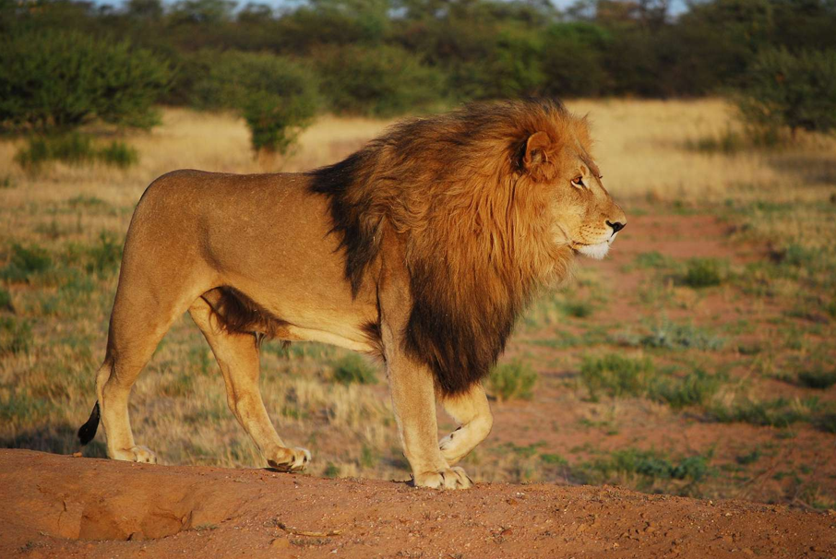
OUTPUT:
